**ABSTRACT**

Club management system is a online portal for the College to manage students, clubs, departments, staff . The idea is to make the college club activities from traditional offline method to convenient and efficient online method. All together making a complete web based application which provides a single platform for all clubs, students, mentors and office bearers for working and functioning very effectively.

**TABLE OF CONTENTS**

**Chapter Page no.**

**1. CERTIFICATE 4**

**2. ACKNOWLEDGEMENT 5**

**3. INTRODUCTION 6**

**4. PROBLEM STATEMENT 7**

**5. DATABASE DESIGN 8-9**

**6. FRONTEND TECHNOLOGY 10**

**7.BACKEND TECHNOLOGY 11**

**8.SCREENSHOTS 12-14**

**9.CONCLUSION 15**

**10.REFERENCES 16**

**CERTIFICATE**

Certified that the project work carried out by bonafide students of in fulfillment for the Database Management System lab in Computer Science and Engineering during the academic year 2019-2020.

Signature of the Examiners:

Signature of the Guide:

1.

2.

**ACKNOWLEDGEMENT**

The satisfactions that accompany the successful completion of any task would be incomplete without the mention of the people who made it possible. So we acknowledge all those whose guidance and encouragement served as a beacon of light and crowned our efforts with success.

We are thankful to our project guide, Ms. Anusha Anchan, Dept. of CSE and Ms. Ankitha A Nayak for their valuable guidance and advice. Their willingness to motivate us contributed tremendously to our project.

We would like to place on record our deep sense of gratitude to Dr. K. R. Udaya Kumar Reddy, HOD-Dept. of Computer Science and Engineering, NMAMIT, Nitte for his generous guidance, help and useful suggestions. We also acknowledge and express our sincere thanks to our beloved Dr. Niranjan. N. Chiplunkar, Principal, NMAMIT, Nitte who is a source of inspiration to us.

We thank all the Teaching and Non-Teaching staff members of the department of CSE for providing resources for the completion of the project. A special thanks goes to our parents, friends and relatives for supporting and encouraging us in all ways thus making our project successful. Finally, we thank all those who have contributed directly or indirectly in making this project a grand success.

**CHAPTER 1**

**INTRODUCTION**

* There are four pathways in the web app namely Admin, Mentors, office bearers and students.
* The application provides privileges for the College ie., Admin to maintain all records related to students, clubs, departments, mentors , staffs and related details.
* Mentors select the office bearers for their particular club. They also approve the events organized by the club which in-turn makes registration lines open.
* The office bearers duty is to check the availability of venue and book the hall accordingly. He/She then creates the event and mentions all the details in the description for the mentor approval and registration to be taken. Office bearers can view the registrations and details of the registered students.
* Students get to view the events and can filter out the events with respect to departments and hence can register to any particular event they are interested in.

**CHAPTER 2**

**PROBLEM STATEMENT**

In most of the college there are so many clubs which host and organize so many events which is not planned out properly. There are venue confusions. Two or more events clash with each other making the students confused about which event to attend. Event registration process is also very hectic and not so easy to approach in nature. The hallbooking process is also a very big task for the organizers. So our online club management system gives solution for all these problems faced on one single platform.

**CHAPTER 3**

**DATABASE DESIGN**

**ER-Diagram**

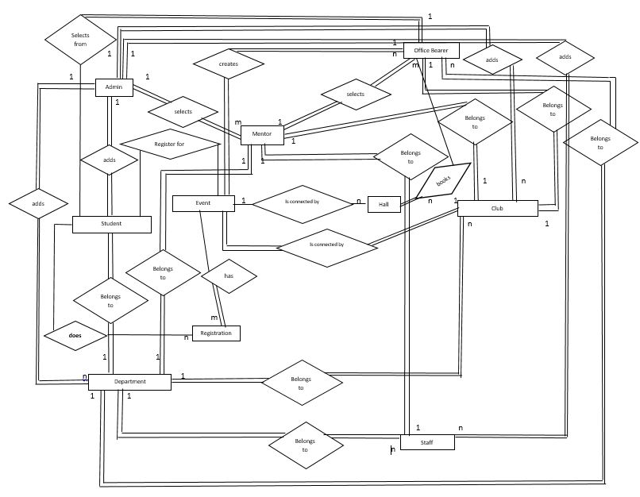

**SCHEMA**

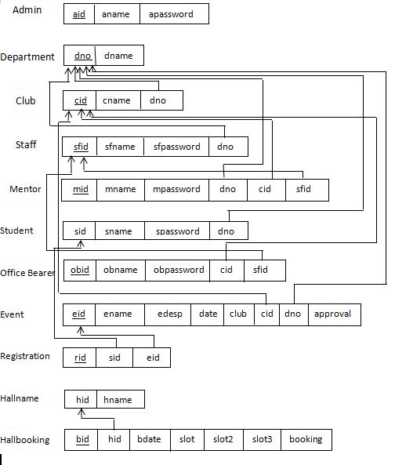

**CHAPTER 4**

**FRONTEND TECHNOLOGY**

**List of technologies for frontend**

**1. HyperText Markup Language(HTML)**

Hypertext Markup Language is the standard markup language for creating web pages and web applications.

**2. Cascading Style Sheets(CSS)**

Cascading Style Sheets is a style sheet language used for describing the presentation of a document written in a markup language like HTML

**3. JavaScript**

JavaScript, often abbreviated as JS, is a high-level, interpreted programming language. It is a language which is also characterized as dynamic, weakly typed, prototype-based and multi-paradigm.

**CHAPTER 5**

**BACKEND TECHNOLOGY**

**List of technologies for Backend**

**1.PHP**

Hypertext Preprocessor is a server-side scripting language designed for Web development, and also used as a general-purpose programming language. It was originally created by Rasmus Lerdorf in 1994, the PHP reference implementation is now produced by The PHP Group.

**Database:**

**MySQL:**

MySQL is an open-source relational database management system. Its name is a combination of "My", the name of co-founder Michael Widenius's daughter, and "SQL", the abbreviation for Structured Query Language.

**Chapter 6**

**SCREENSHOTS**

1. **Home Page**

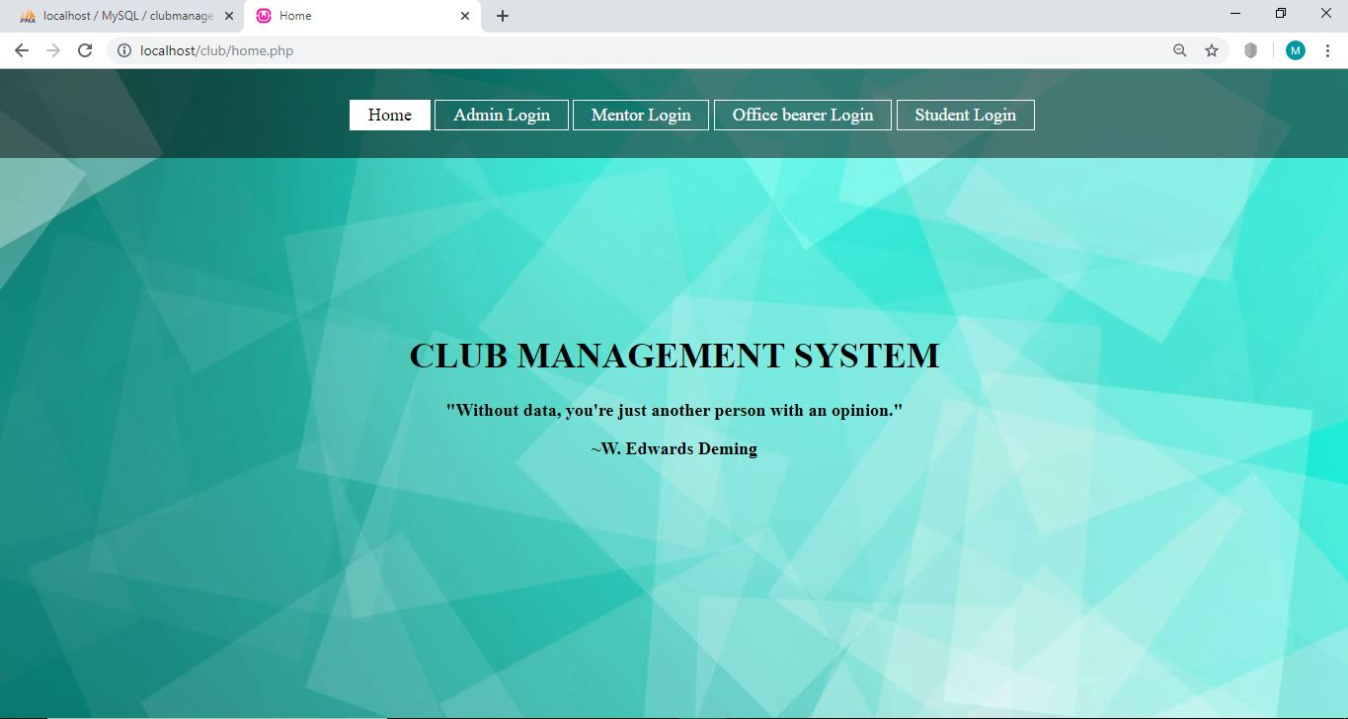

1. **Admin Login Page**

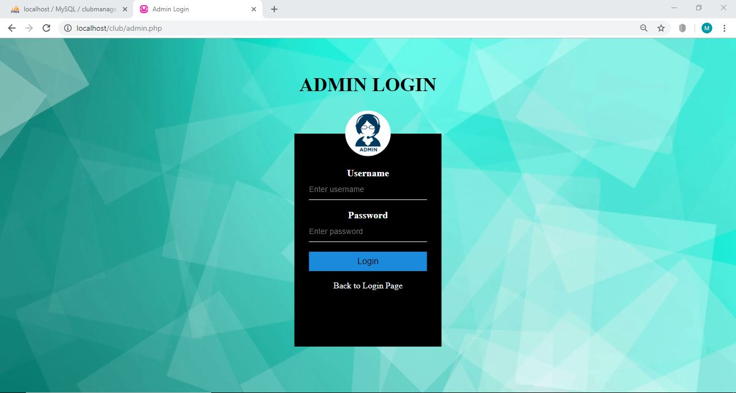

**3. Admin Dashboard**

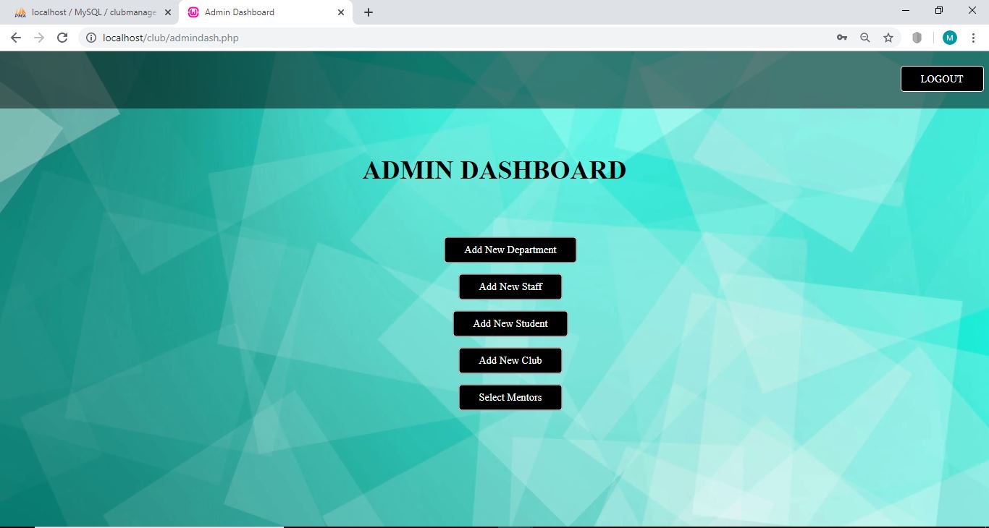

1. **Mentor Dashboard**

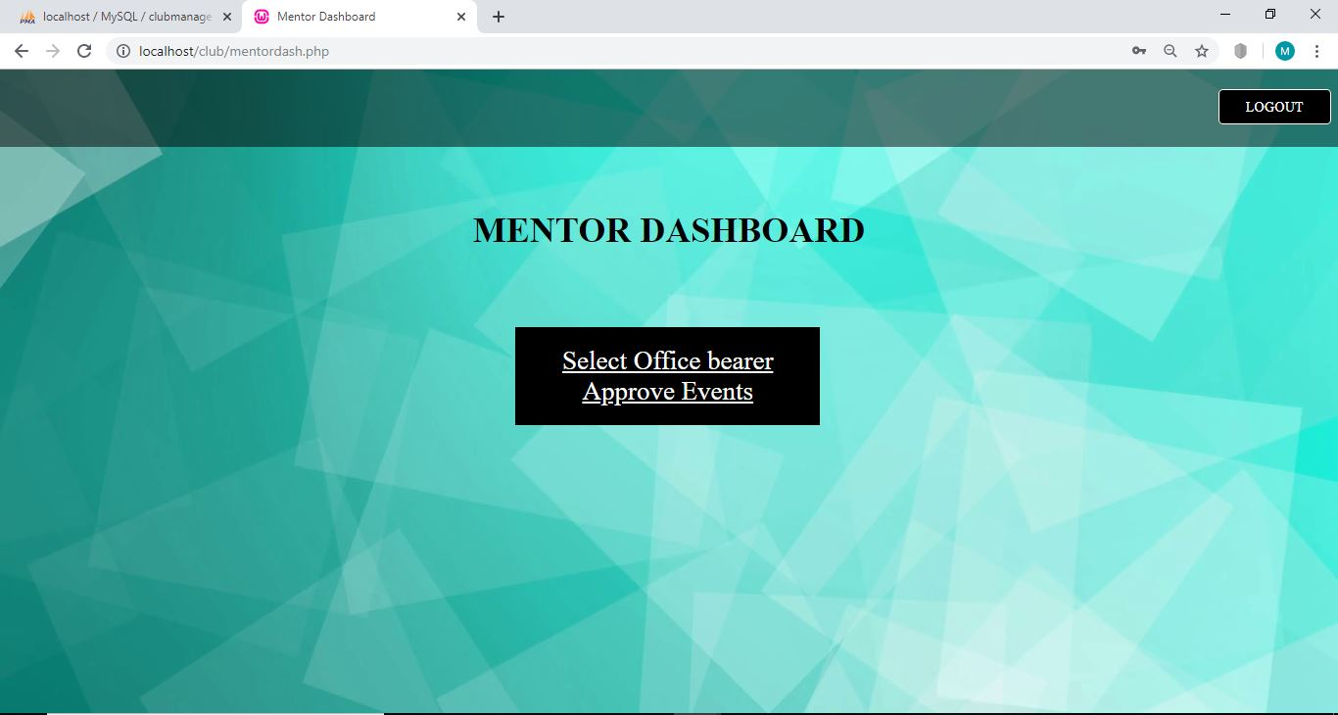

1. **Office Bearer Dashboard**

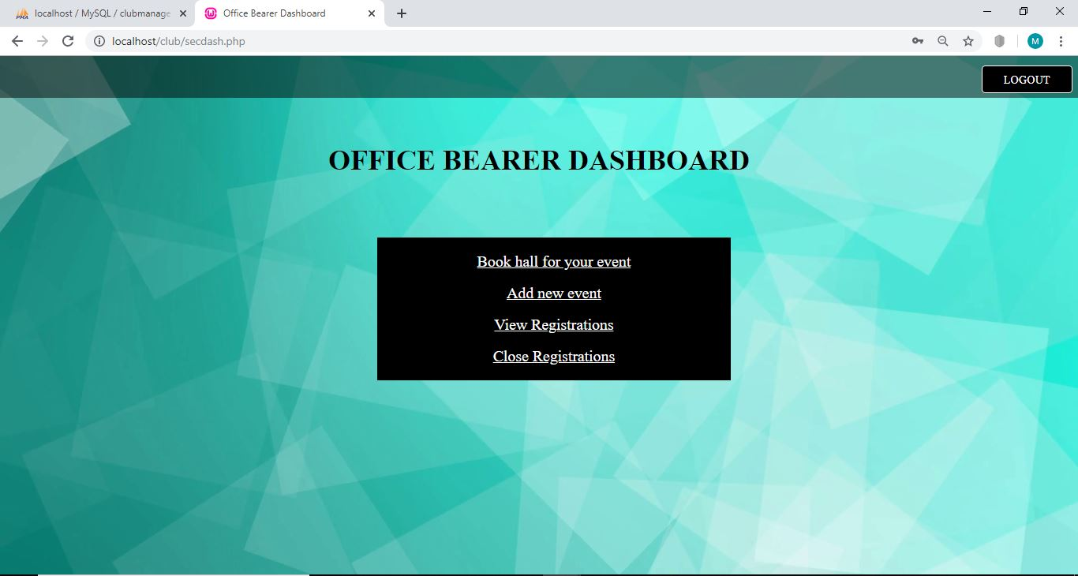

1. **Student Dashboard**

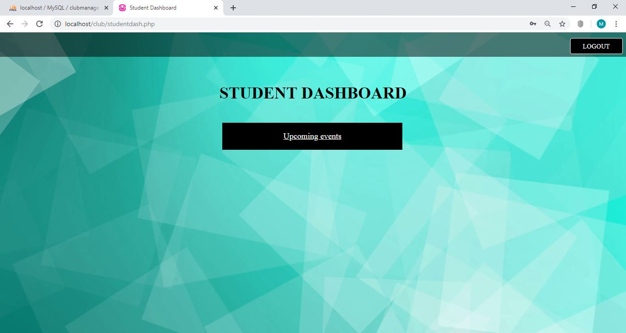

**CHAPTER 7**

**CONCLUSION**

Overall the Application gives solution for all the drawbacks and problems faced in club management and event organization. By allowing multiple users to approach the details and do registrations at the same time and giving all the information for all the users at same platform makes it efficient. There is no need for running around for registration, approval etc, making the application very effective in terms of time saving. Also the college gets all the details of club in single place. Hence we conclude our project on Online Club Management System with all the features as a Solution to the Problem statement mentioned above.

**CHAPTER 8**

**REFERENCES**

1. PHP and MySQL Web Development- Book by Luke Welling
2. Stackoverflow
3. W3schools
4. Php tutorial